t_{i} | = | Time of loading | 7 | 7
t_{ps} | = | Time of temporary strand removal and diaphragm casting | 30 | 90
t_{s} | = | Time of slab and diaphragm placement | 40 | 120
t_{f} | = | Final creep time | 2000 | 2000

Cast-in-place Deck

Release to Deck Placement
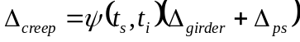

Camber
Immediately after Prestress Release 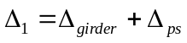
Immediately before deck placement 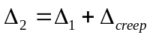
Immediately after deck placement 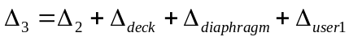
Immediately after superimposed dead loads 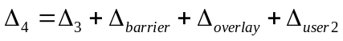
Excess Camber 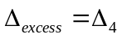
Deflection immediately before deck placement 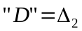
Screen Camber 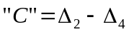

Cast-in-place Deck – Girder with Temporary Strands

Release to cutting of temporary strands
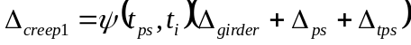

Temporary strands cut to Deck Placement

Camber
Immediately after Prestress Release
Immediately before cutting temp strands 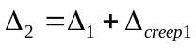
Immediately after cutting temp strands 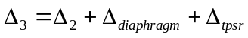
Immediately before deck placement 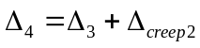
Immediately after deck placement 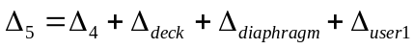
Immediately after superimposed dead loads 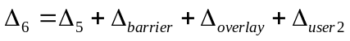
Excess Camber 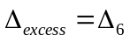
Deflection immediately before deck placement 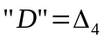
Screen Camber 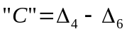

Stay-in-place Deck Panels

Release to Deck Placement

Camber
Immediately after Prestress Release
Immediately before deck placement
Immediately after deck placement
Immediately after superimposed dead loads
Excess Camber
Deflection immediately before deck placement
Screen Camber

Stay-in-place Deck Panels – Girder with Temporary Strands

Release to cutting of temporary strands

Temporary strands cut to Deck Placement

Camber
Immediately after Prestress Release
Immediately before cutting temp strands
Immediately after cutting temp strands
Immediately before deck placement
Immediately after deck placement
Immediately after superimposed dead loads
Excess Camber
Deflection immediately before deck placement
Screen Camber

No Deck

Release to Diaphragm Casting
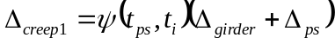

Diaphragm Casting to Superimposed Dead Loads

Superimposed Dead Loads to Final
Camber
Immediately after Prestress Release
Immediately before diaphragm casting
Immediately after diaphragm casting 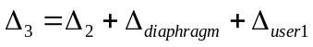
Immediately before superimposed dead loads (C_{i})
Immediately after superimposed dead loads 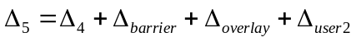
Final (C_{F+SIDL}) 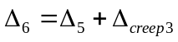
Excess Camber
Deflection immediately before deck placement
Screen Camber

No Deck – Girder with Temporary Strands

Release to Temporary Strand Cutting

Temporary Strand Cutting to Superimposed Dead Loads

Superimposed Dead Loads to Final
Camber
Immediately after Prestress Release
Immediately before cutting temp strands
Immediately after cutting temp strands
Immediately before superimposed dead loads
Immediately after superimposed dead loads 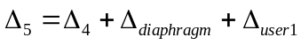
Immediately after superimposed dead loads
Excess Camber
Deflection immediately before deck placement
Screen Camber

